Job Title | Practice Manager
Reports To | National Health Manager
Group | Phoenix Health Hub
Location | Moorhouse Ave Christchurch
Direct Reports | Administrators
Key Relationships | Internal: Clinical Team, Shared Services Teams: HR, Training, Finance, Marketing, Quality and Leadership Teams.  External: Funders, NGOs, Industry bodies, Training Partners

OUR ORGANISATION
At Phoenix Healthcare, we don’t take health for granted. We strive to provide the very best healthcare to improve your quality of life and optimise the everyday health of our community.

Working together for better health outcomes, we’re proud to offer a range of accessible healthcare services from general practice to home-based care and workplace health services to support the health and wellbeing of you and your family/whanau at home, at work and throughout your life.

IMPROVING LIVES TOGETHER – TE WHAKAPAI I TE ORA TAHI
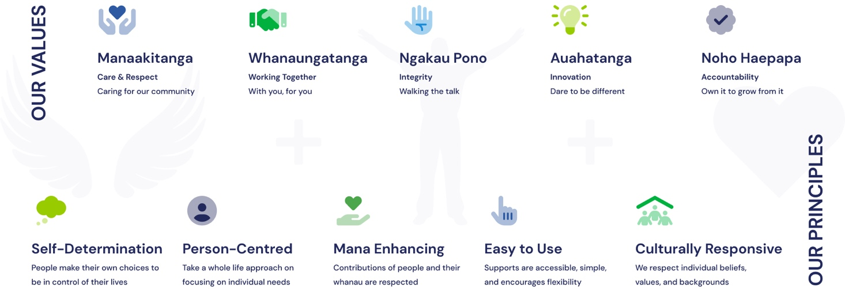

POSITION PURPOSE
The Practice Manager at Phoenix Health Hub will ensure seamless operational management and enhance service delivery across the GP and Health Hub Services. By providing effective leadership, guidance, and mentorship, the Practice Manager will cultivate a collaborative and efficient administration team. This role will focus on optimising workflow, fostering positive stakeholder relationships, and implementing strategic initiatives to continuously improve patient care and service outcomes. Key objectives include upholding high standards of compliance, promoting a healthy and safe working environment, and driving operational performance to support the sustainability and growth of the Phoenix Health Hub.

ROLE SCOPE
Responsible for the leadership, operational efficiency, and enhancement of service delivery of the Phoenix health Hub. Providing leadership to the administration team and aligning with our clinical service to ensure optimised patient care, delivery and outcomes.

KEY RESPONSIBILITIES
Effective Team Leadership
In collaboration with Clinical Leads, provides guidance towards the team's effectiveness by providing leadership, support, and mentorship; aimed at continually improving service delivery and performance of the Phoenix Health Hub.

Responsibilities include ensuring:

- The team are kept informed of communication, workflow optimisation, and expectations.
- Supporting and implementing change management functions and project delivery.
- The provision of expert guidance and support toward stakeholders’ rights and obligations within the service and sector.
- Effective management of partnerships with positive relationship building of referral sources to ensure a pipeline of consistent client referrals built on trusted relationships.
- The coaching, mentorship, and training of administration staff.
- Regular goals are set with the team towards the service delivery requirements and understanding of measurable outcomes.
- Working relationship with the Clinical Leads on related staff and or client issues for quick resolution.
- Mediation of interpersonal disputes.
- Team compliance towards process, policies, and procedures.
- Team awareness and adherence to all employment Health and Safety legislation.
- Promotion and support of initiatives that contribute to a healthy and safe working environment, including accident and incident reporting, investigation, and hazard management.
- Financial liability is reduced via effective service delivery.

Administration and Reporting
The purpose is to maintain up-to-date and timely completion of reports, reviews, and records for service delivery. Responsibilities include providing reports or communication updates on the:

- Monitoring and reporting on referral metrics as requested.
- Reporting and compilation on service delivery such as: appointments utilisation, revenue streams, funding, and patient demographics.
- Collaborate with finance teams to ensure budget and targets are met and within scope.
Application of Service Delivery Operations
As the Practice Manager, lies the responsibility for the effective implementation of client-centric service delivery outcomes.

Responsibilities include ensuring:

- Create and communicate regarding the purpose, objectives and success factors of the organisation.
- Work closely with the Manager and Clinical Leads to deliver new and enhanced services to patients.
- Oversee that the workforce planning requirements, meet patient needs requirements through effective operations.
- Ensures workforce challenges are managed and escalated to the Manager where and when action is required beyond service delivery norms.
- Ensure the balanced management of funding contracts and actively work to improve the financial performance where opportunity arises.
- Implementation of systems, processes, and procedures are embedded into practice with review time for evaluation to ensure best practice.
- Stress reduction practices are taking place and escalation management and shared workload distributions are in place.
- Remodelling of expectations and professional boundaries, championing equity.
- Ensures the overall efficiency of rostering requirements, including building capacity and capability to meet the needs of patient operations.
- Facilitate regular meetings with a whole team approach to ensure optimal communication is kept across Phoenix Hub roles.
- Monitor patient feedback and ensure it is kept in planning and actions towards rectification and quality improvement.
- Ensure compliance with infection control protocols, safety measures and emergency planning for best outcomes.
- Monitor and evaluate financial performance, to identify potential cost savings and efficiencies of spending.
- Work with the Manager and HR to identify training needs and professional development opportunities for administration staff.

CULTURAL COMPETENCIES
- Cultural Awareness: Understand and respect diverse cultural backgrounds.
- Acknowledge Māori as Tangata Whenua and the Treaty of Waitangi.
- Recognise and mitigate cultural biases.
- Cultural Safety: Create an environment of respect and value for all cultures.
- Leadership and Advocacy: Promote cultural competence and inclusivity.
- Community Engagement: Build relationships with diverse community groups and local iwi.
- Regularly update policies to follow best practices.
- Support staff development in cultural understanding.
- Foster a supportive environment for discussing cultural concerns.
- Evaluation and Improvement: Continuously evaluate and improve cultural competence through feedback.
- Stay informed on best practices in cultural competence in healthcare.

KEY RELATIONSHIPS
Internal | Collaborates with Administrators, Clinical team and Clinical Leads, Recruitment / HR, Executive and Senior Leadership Team.
External | Engages with clients and their families, referral agencies, health sector professionals, and other necessary external stakeholders.

QUALIFICATIONS & EXPERIENCE
Educational Background | Ideally a qualification in management, healthcare, administration or a similar field (or proven equivalent work experience)
Experience | Ideally healthcare management or sound service delivery sector leadership
Legislation and Policy Knowledge | Comprehensive understanding of healthcare regulations, Privacy Act 2020, and familiarity with the Treaty of Waitangi principles
Leadership Skills | Strong leadership, organisational, project planning, and implementation
Problem-Solving | Innovative thinking and problem-solving skills to address operational situations
Communication | Excellent interpersonal communication skills, with an emphasis on discretion, tact, diplomacy, and influence
Health and Safety | Knowledge of health and safety standards in healthcare or similar field
Cultural Sensitivity | Demonstrated cultural awareness and sensitivity
Professional Development | Commitment to continuous learning and staying updated with healthcare trends and policies

KEY COMPETENCIES
Organisational and Time Management | Skilled at organising tasks, prioritising efficiently, and thriving under pressure. Adaptable to changes and keen on optimising systems
Computer Literacy | Proficient in Office software (Word, Excel, Outlook), with a preference for experience in scheduling tools
Interpersonal and Team Skills | Open, inclusive, and supportive, and a highly developed emotional intelligence. Resilient and open to changes
Communication | Excellent communicator in verbal and written communication, with a professional demeanour on calls and written communication
Client Service Focus | Dedicated to exceptional service for diverse clients, excelling in building strong relationships
Problem Solving | Innovative in identifying and solving problems, committed to efficient and creative solutions
Personal Attributes | Committed to the organisation's mission, detail-oriented, positive, and focused on continuous growth
Teamwork | Strong desire to enhance team cohesion and service quality through active participation and innovation in team initiatives
Confidentiality Commitment | Maintain strict confidentiality of all client and staff data in compliance with legal standards and organisational policies
Health & Safety Aim | Champions health and safety accountability, adheres to policies, reports and manage workplace risks, and contributes to a safe work environment
This position description is not a complete and exhaustive list of tasks but represents the nature of the position.

